Homework XX
(due MM DD, 2014)
Send your questions and homework to Kyo via email (huikyo.lee@jpl.nasa.gov).

Global climate models (GCMs) and regional climate models (RCMs) are fundamental tools for studying future climate change. Despite substantial improvement in GCMs gained by better understanding and representation of climate system, models still contain biases and uncertainties. To better constrain these uncertainties, further observationally-based model evaluation is essential.
The Regional Climate Model Evaluation System (RCMES) is a software package developed to facilitate climate model evaluation via easy access to observations from surface stations and NASA remote sensing datasets as well as assimilations and reanalyses. A detailed description about RCMES and its applications to regional climate research can be found in Kim et al. [2013], and in the website (http://rcmes.jpl.nasa.gov/).

1. Taylor diagram (5 points)
You may see Taylor diagrams in many model evaluation papers. Taylor diagram visualize models' performance against observational data. Please read Taylor [2001] and answer the following questions.

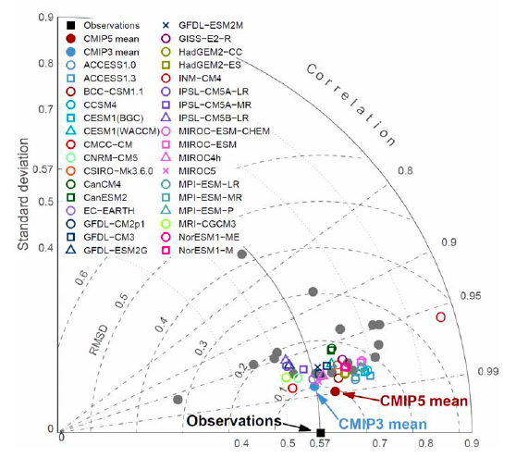
Example Taylor diagram (Figure 9.16 from the latest IPCC report)
The Taylor diagram summarizes three different metrics that describe similarity between observational and model data. What are they? How are the three metrics related to the x, y and curved axis of the Taylor diagram?

2. RCM evaluation report (15 points)
RCMES can replicate all the figures used in Kim et al. [2013]. Draw maps of observational data, model biases and a Taylor diagram to evaluate temperature climatology of six NARCCAP (https://www.narccap.ucar.edu) models between 1981 and 2003 using CRU 3.1 data as reference. Which model performs best? Is there any benefit of using an ensemble of multiple models? Which model would you choose to make future projections over North America (explain why)? Your report should be no more than two pages long without figures. You can use RCMES to process the data and make the plots.

References

Kim, J. and Coauthors (2013), Evaluation of the Surface Climatology over the Conterminous United States in the North American Regional Climate Change Assessment Program Hindcast Experiment Using a Regional Climate Model Evaluation System. J. Climate, 26, 5698–5715, doi: http://dx.doi.org/10.1175/JCLI-D-12-00452.1.

Taylor, K. E. (2001), Summarizing multiple aspects of model performance in a single diagram, J. Geophys. Res., 106(D7), 7183–7192, doi:10.1029/2000JD900719.

How to run RCMES?

The RCMES installed on Manabe (manabe.atmos.uiuc.edu) is a customized version for this homework. You can copy and change the source codes for your own work. RCMES team will appreciate your comments or suggestions.

1. Create work and cache directories. All the plots and netCDF files will be saved in your work directory.
ex)
> mkdir RCMES_work
> mkdir RCMES_cache

2. Copy RCMES source codes.
ex)
In your home directory,
> cp -R /home/manabe/users/atmos-kyo/RCMES/rcmes ./

3. Edit ‘narccap.cfg’ in the folder named resources. You only need to change line 2 and 3 (workDir and cacheDir) for this homework. If you want to use a different observational dataset, you can change obsParamID (http://rcmes.jpl.nasa.gov/rcmed/parameters).
ex)
workDir = /home/manabe/users/student/RCMES_work
cacheDir = /home/manabe/users/student/RCMES_cache

4. Add rcmes directory to PYTHONPATH
ex)
> export PYTHONPATH=~/rcmes

5. Run RCMES.
> cd ~/rcmes
> ~atmos-kyo/RCMES/anaconda/bin/python rcmet.py -c ./resources/narccap.cfg

* Start Date: 1980-01-01
* End Date: 2003-12-31
* Then it will start downloading data from RCMES database and reading model output files.
* Calculate area-mean timeseries for subregions? y/n: [n]
Just hit the enter key.
* Want to calculate metrics and plot them?
=> y and enter
* reference data ID: 0
* the data id for evaluation: 1 enter, 2 enter, …., 7 enter, -9 enter

6. In your work folder, you can find four png files and ‘temp_Tseries.nc’, a netCDF file including regridded observational and model data.

